Gallery Article Template
1/35 Diorama named “Brave Heart”
by Sam Wong
--------------------
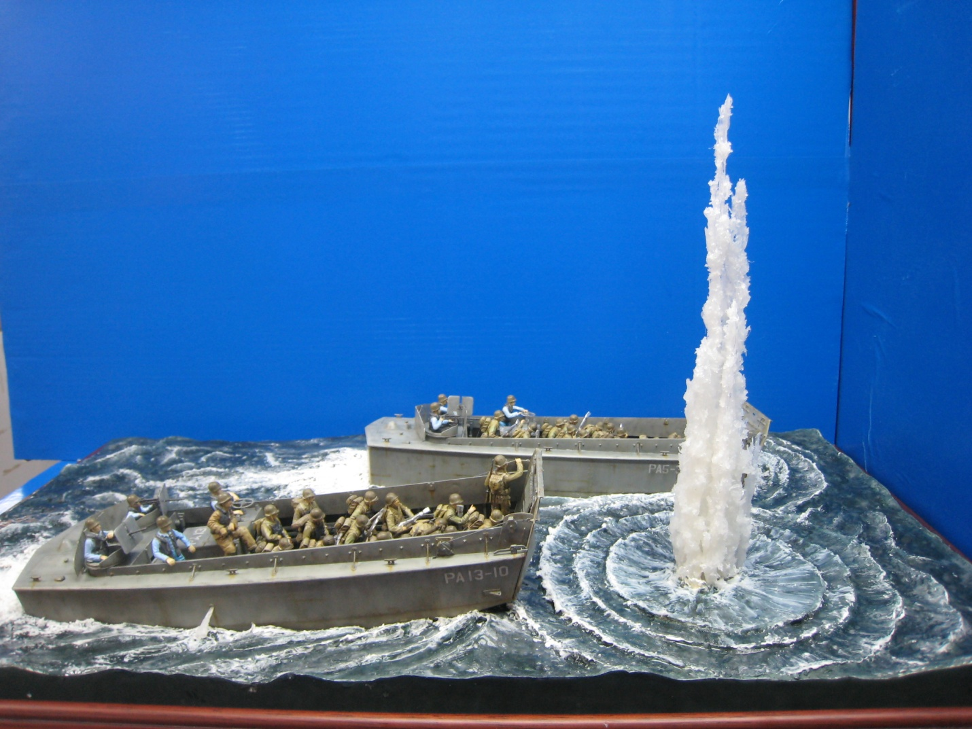
The diorama is based on D-day Allied force invasion Normandy, 1944. Which showing two LCVPs advanced Omaha beach, and a bomb just missed in front of one landing craft.
Steve Bamford will insert 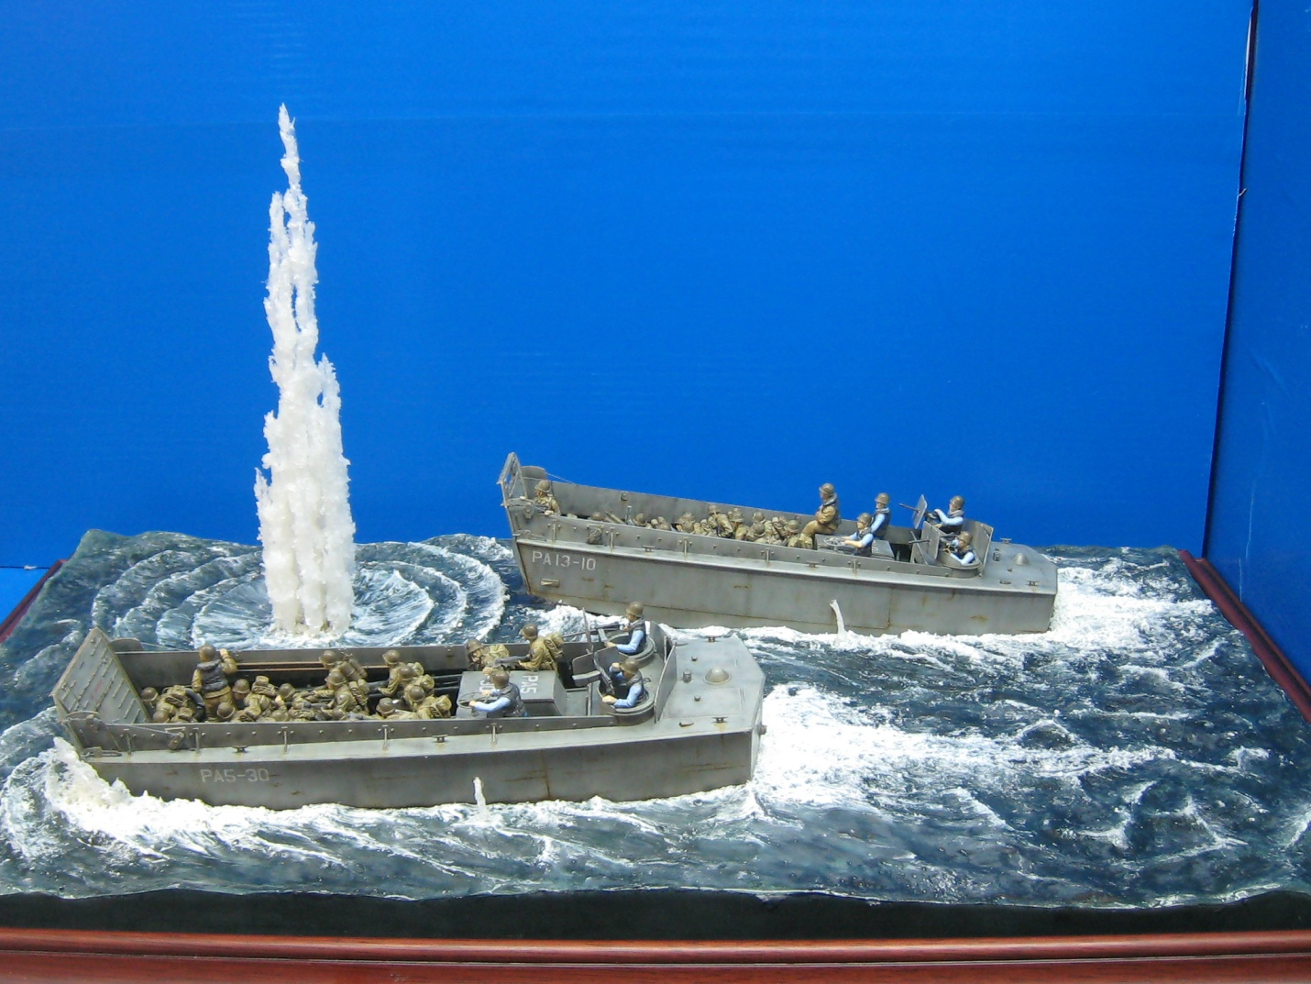a click-able smaller version of photo 03.jpg here. Clicking on that photo will bring up the full sized version of photo 03.jpg | Steve Bamford will insert a click-able 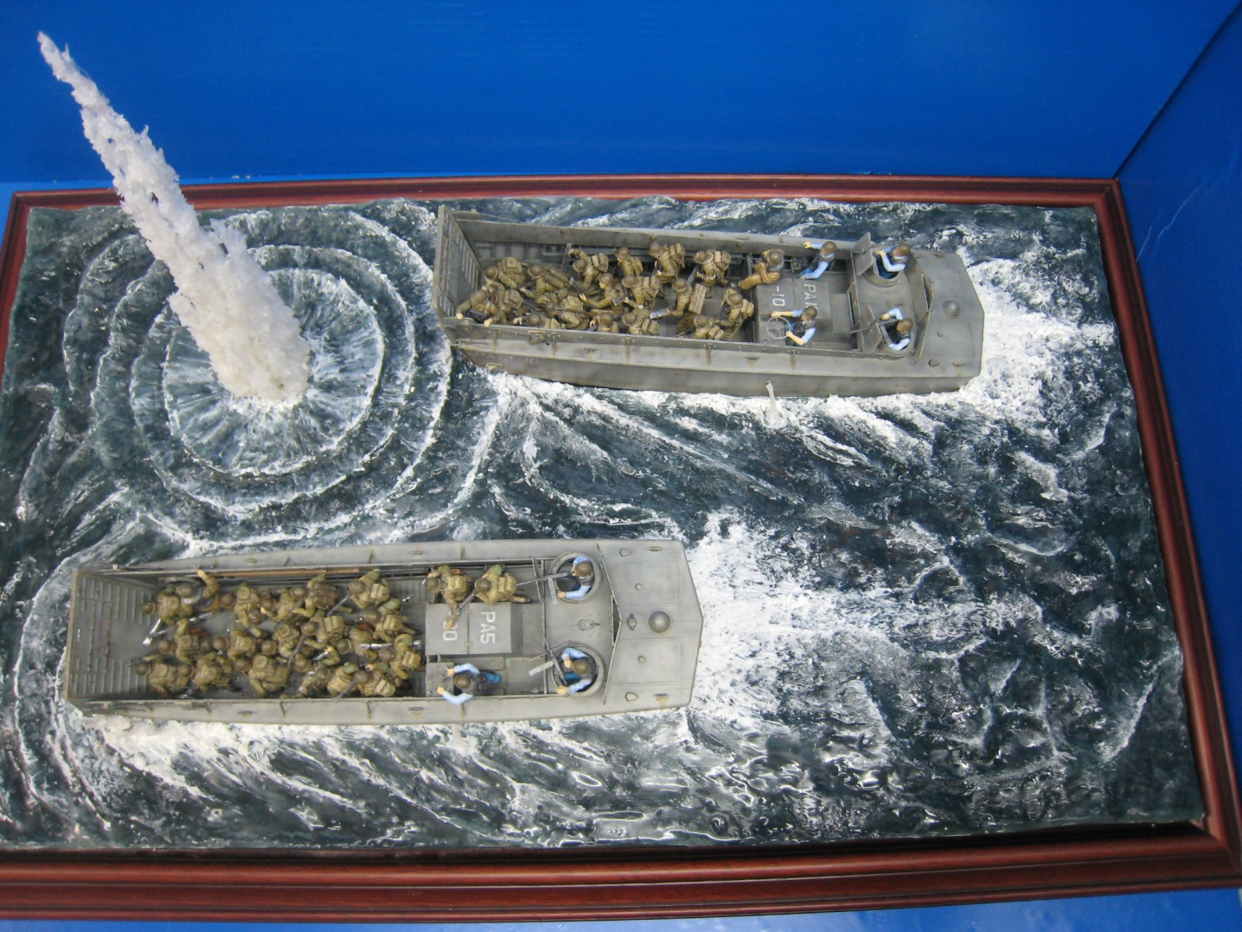smaller version of photo 04.jpg here. Clicking on that photo will bring up the full sized version of photo 04.jpg | Steve Bamford will insert a clic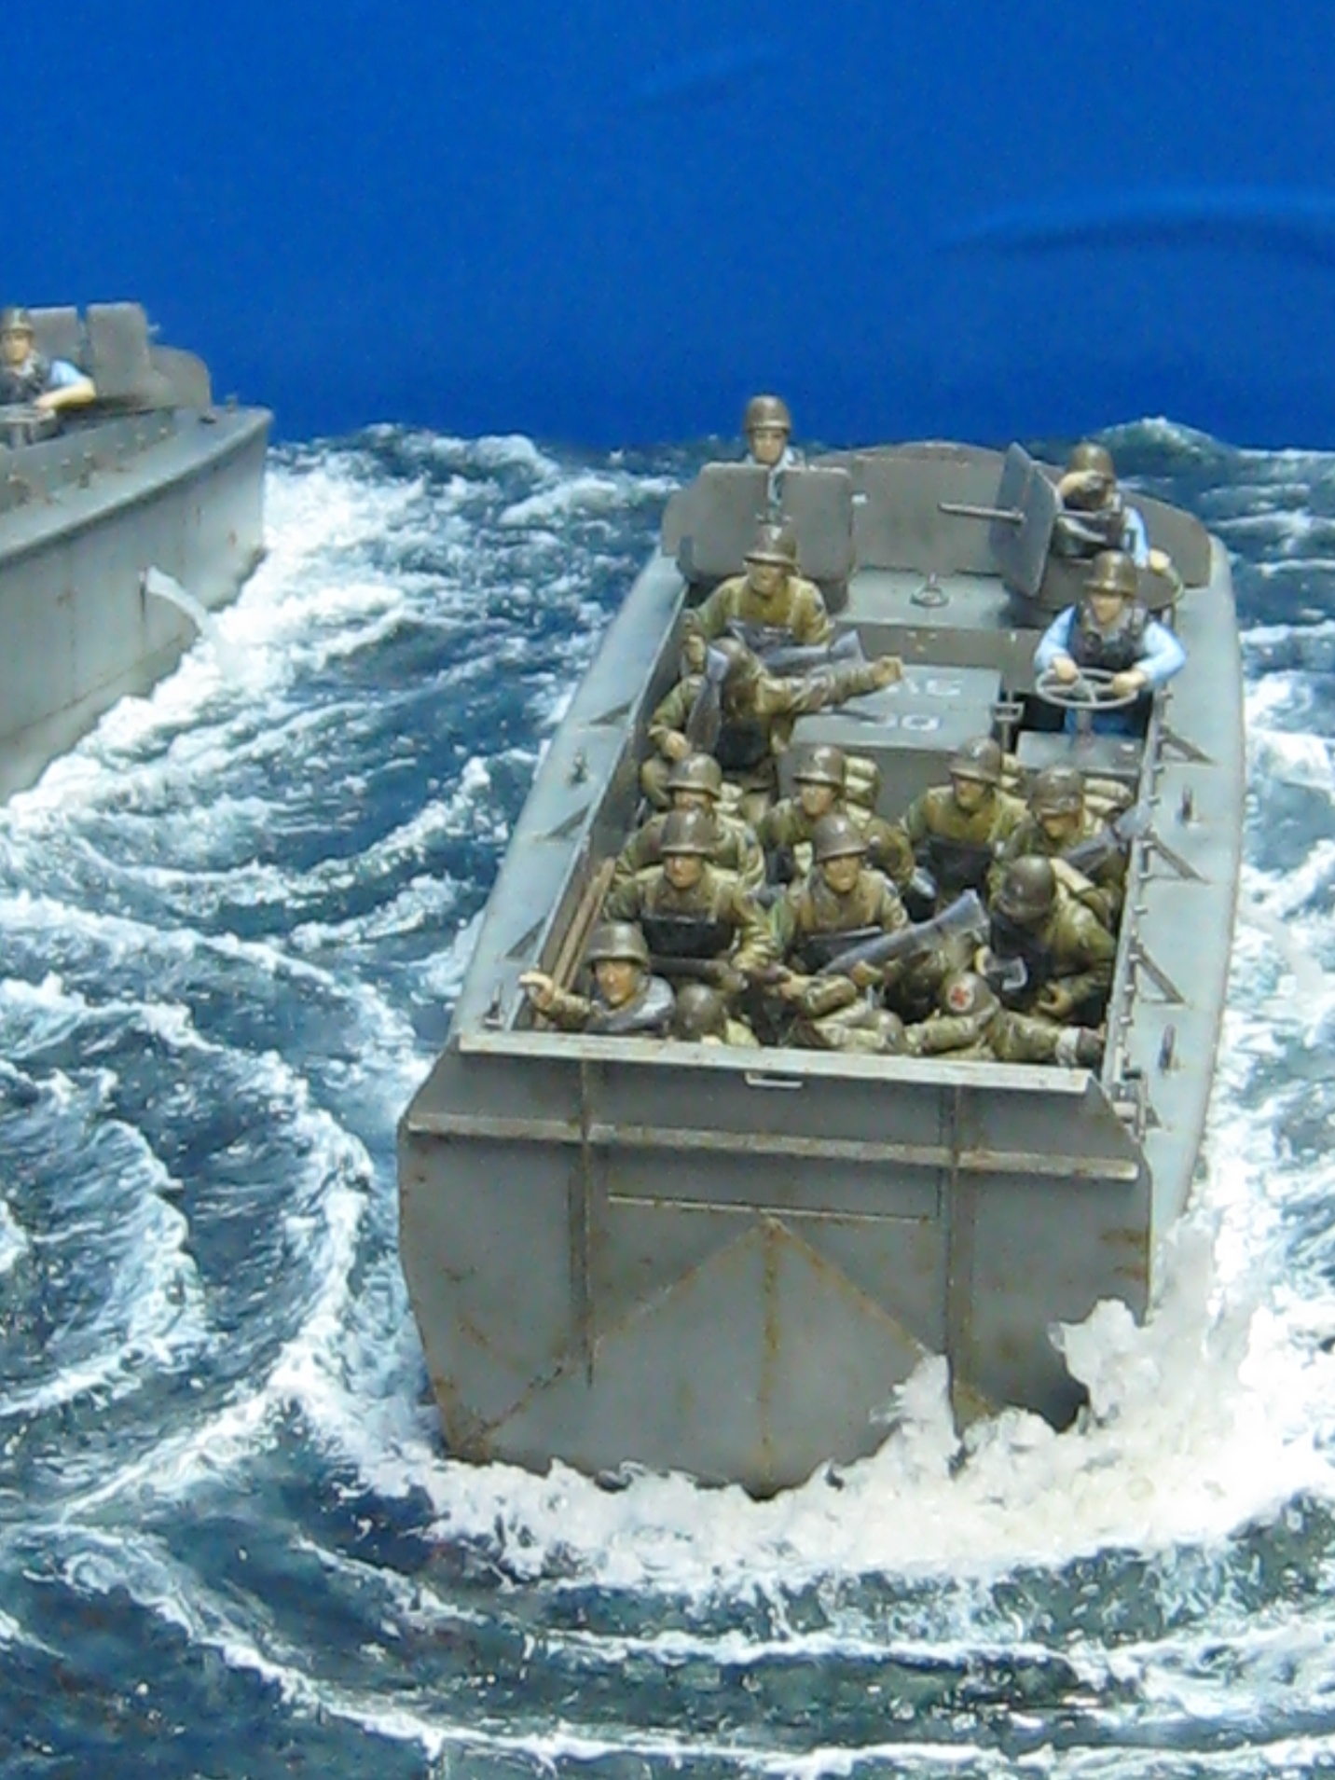k-able smaller version of photo 05.jpg here. Clicking on that photo will bring up the full sized version of photo 05.jpg | Steve Bamford will inse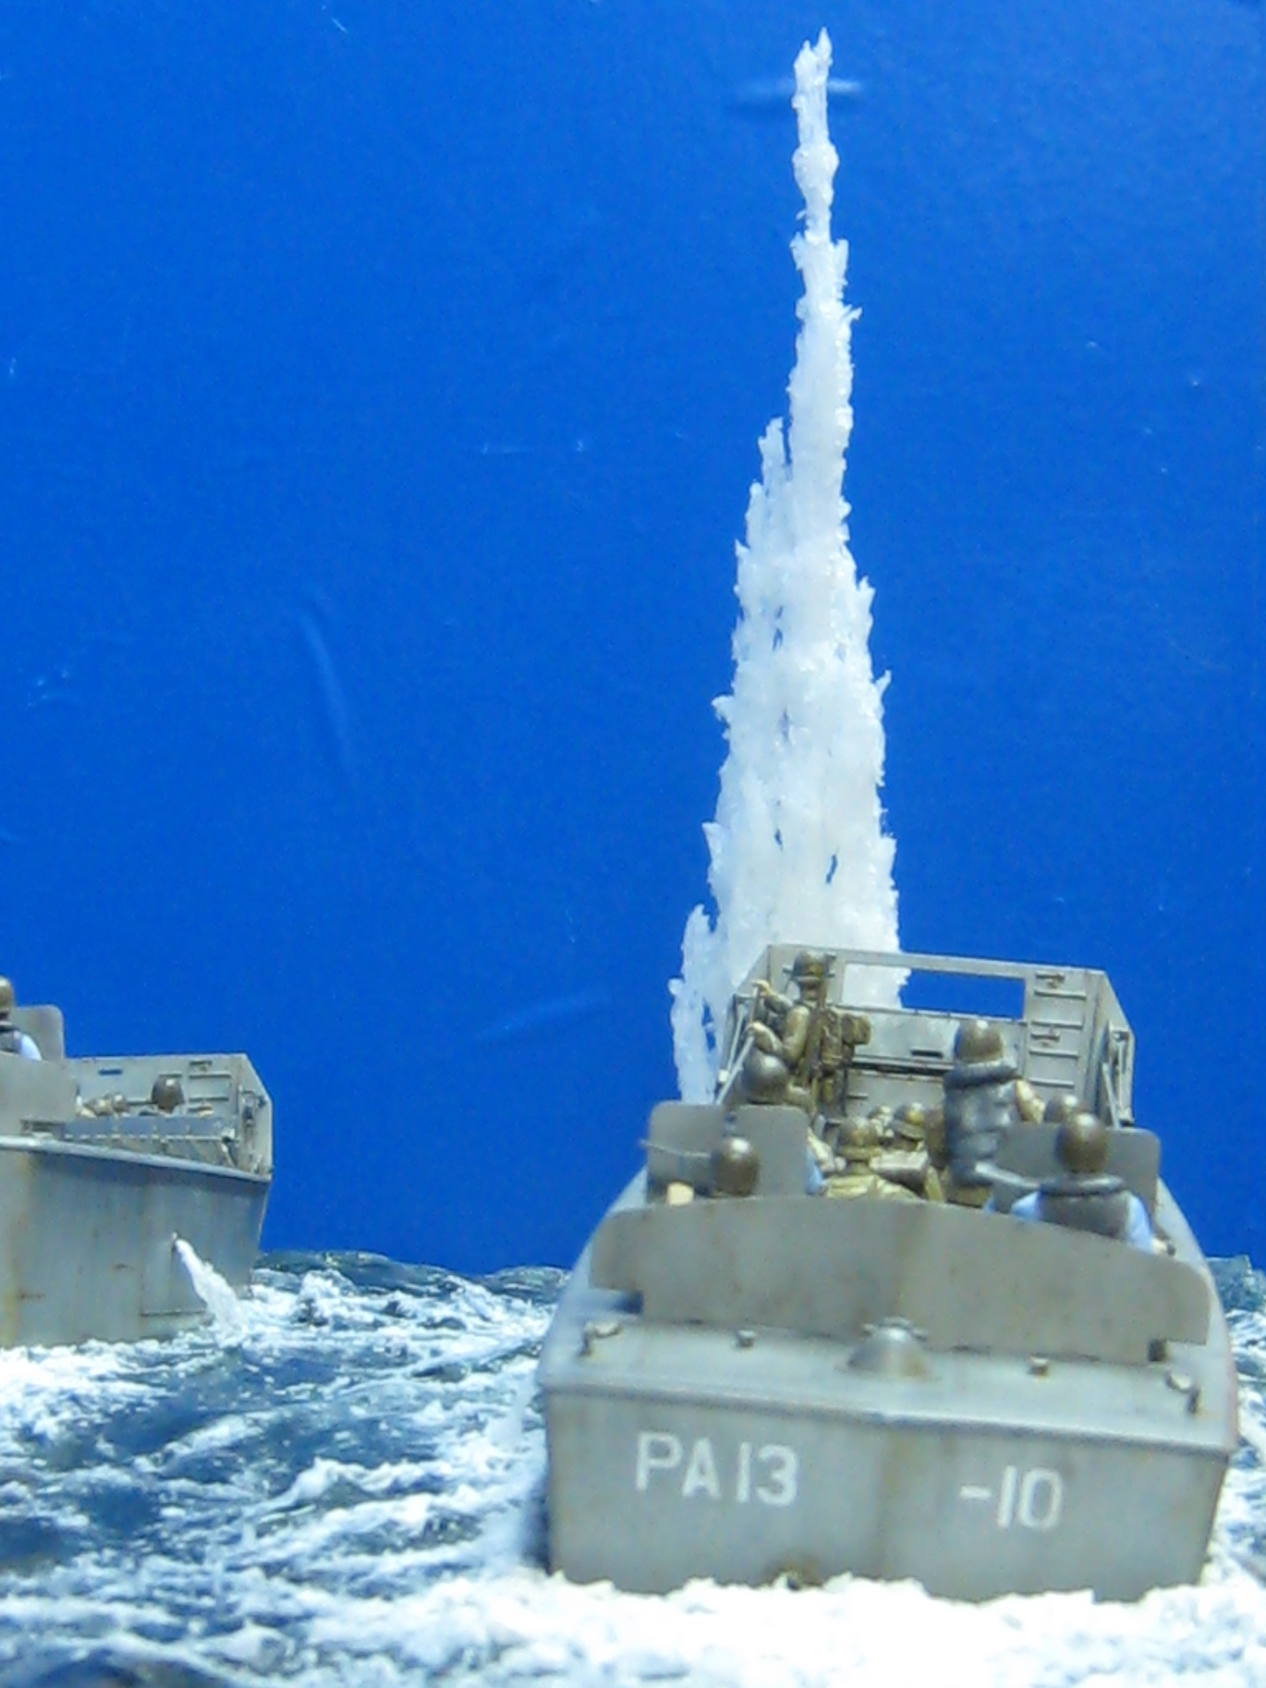rt a click-able smaller version of photo 06.jpg here. Clicking on that photo will bring up the full sized version of photo 06.jpg
I using a 15”x27” plywood as a base, than I using a 2’ thick, and a same size airplane wood, hand crave out a general shape of water wave, after that, I using artist clay to fine tune the shape. Than I painted the whole base with ocean blue color. After that, I airbrushing a different shape of blue color to simulate the depth of water. Finally, I heavy coated a layer of “Future” on overall base.
Steve Bamford will insert full sized version of photo 02.jpg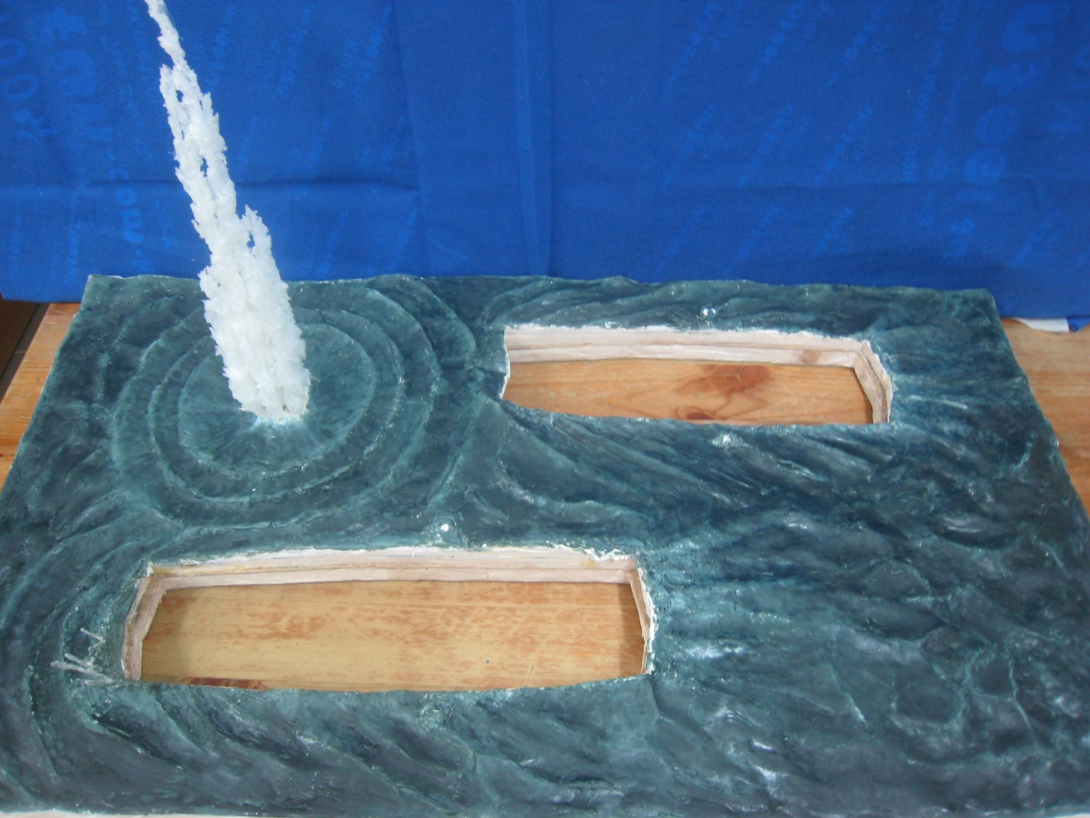 here
The land craft (LCVP) are from Italeri, I pretty much just build it out of the box, each landing craft have about 24 figures, which mean there are total 48 figures, and they are all from Dragon and Miniart, I only converted all figure in different posed, and painted it.
Overall, it’s took me about 4 months to build and finished it, and the most difficult part are working on 48 figures instead of the water wave. But I enjoy every minutes on it. The model win a second place on the Hong Kong 2012 open model competition on the diorama category. I hope everyone enjoy it. Thanks.

Sam Wong 2012
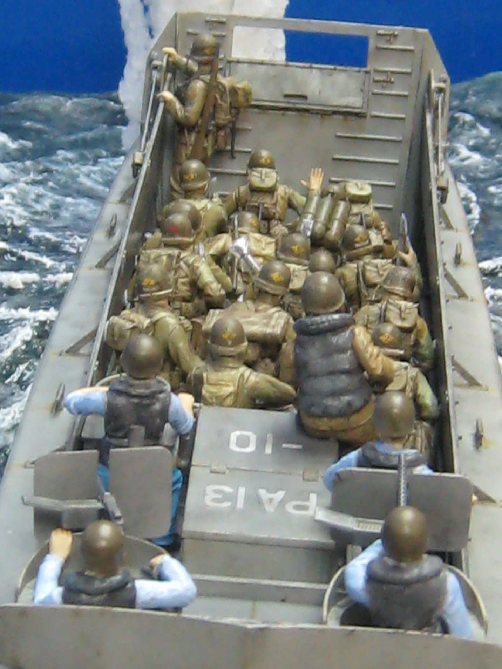 | Steve Bamford will inser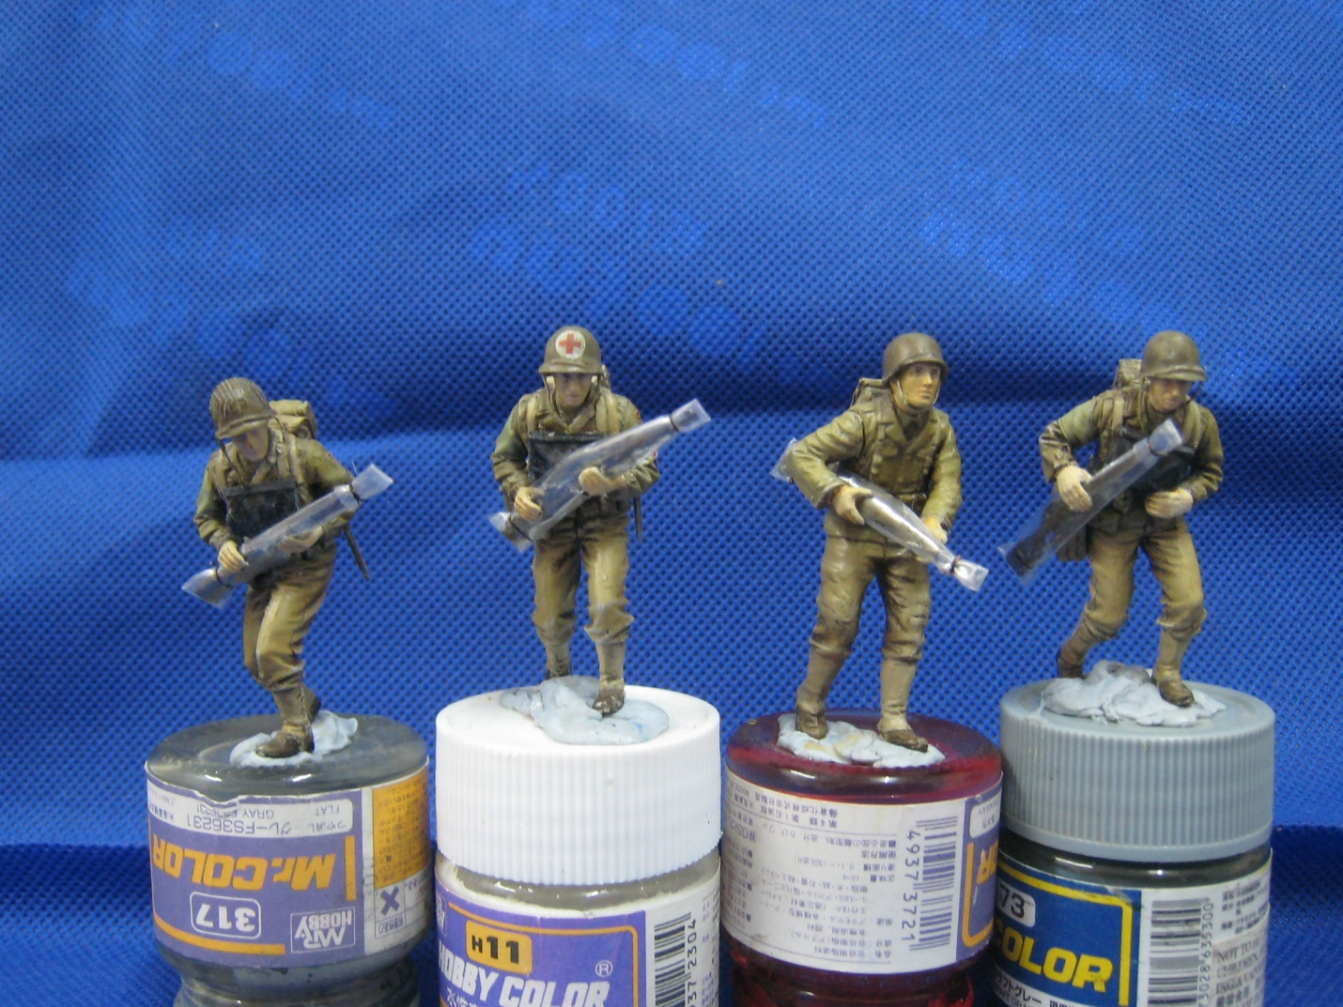t a click-able smaller version of photo 08.jpg here. Clicking on that photo will bring up the full sized version of photo 08.jpg | Steve Bamfor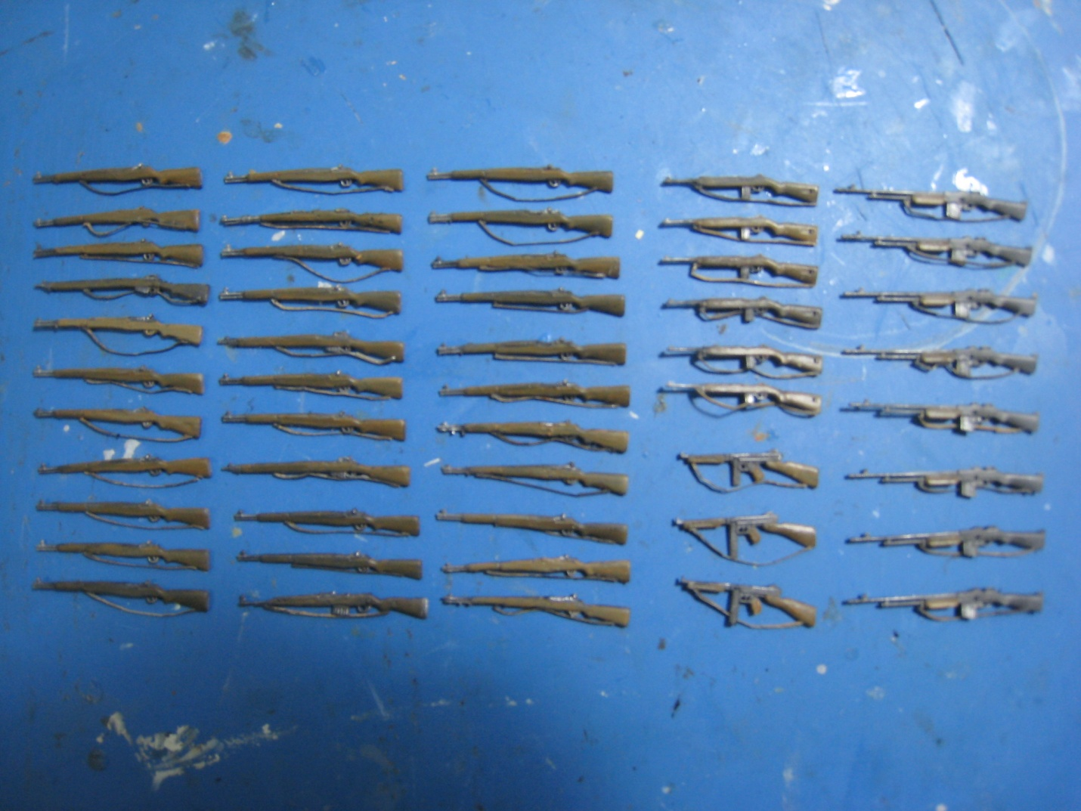d will insert a click-able smaller version of photo 09.jpg here. Clicking on that photo will bring up the full sized version of photo 09.jpg | Steve Bamford will insert a click-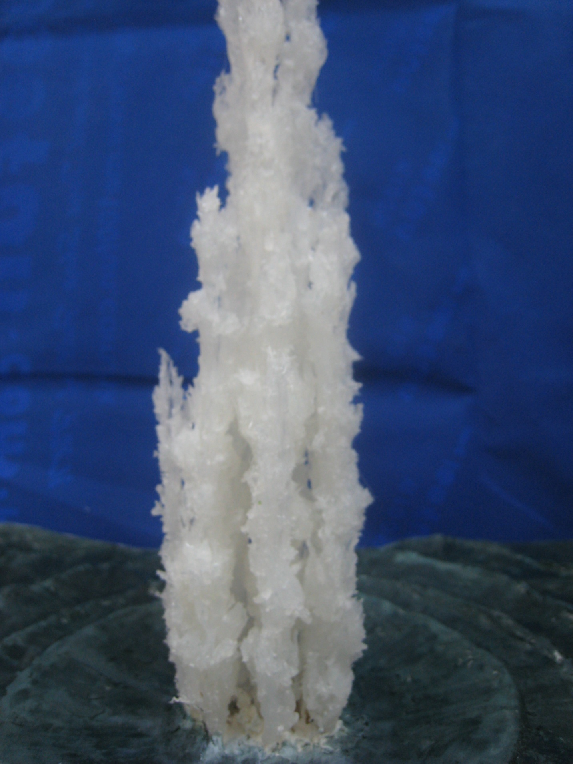able smaller version of photo 10.jpg here. Clicking on that photo will bring up the full sized version of photo 10.jpg
Just delete any of the boxes below you don't need.....it's not important to include them.....they are there to give you an idea of the finished article. It is best to limit your article to no more than 60 or so photos, so the finished webpage won't take too long to open.
Steve Ba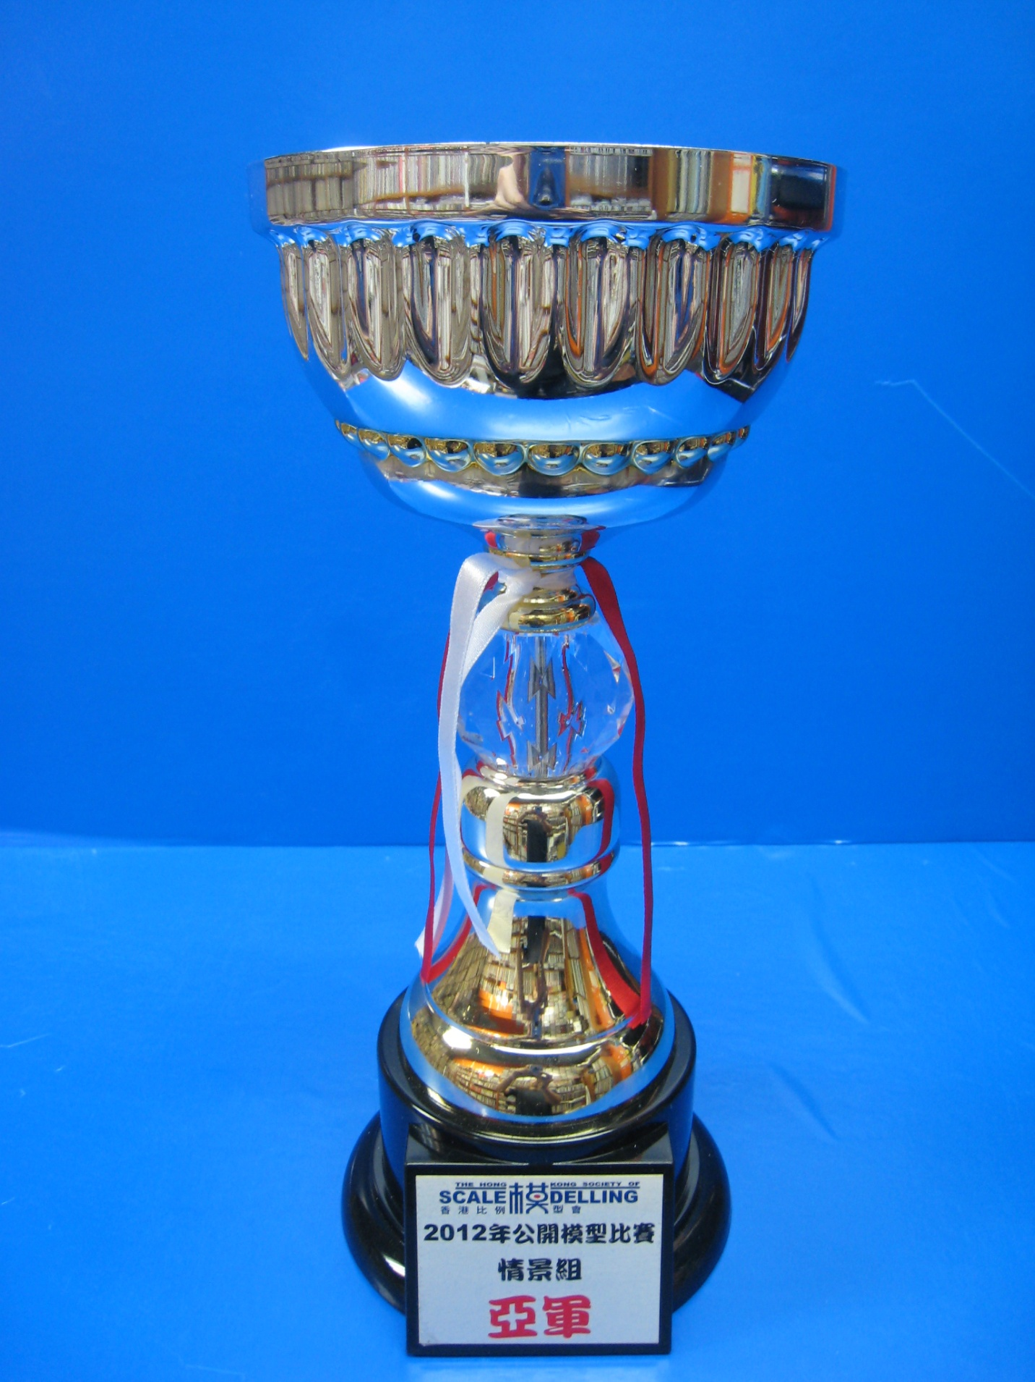mford will insert a click-able smaller version of photo 11.jpg here. Clicking on that photo will bring up the full sized version of photo 11.jpg | Steve Bamford will insert a click-able smaller version of photo 12.jpg here. Clicking on that photo will bring up the full sized version of photo 12.jpg | Steve Bamford will insert a click-able smaller version of photo 13.jpg here. Clicking on that photo will bring up the full sized version of photo 13.jpg | Steve Bamford will insert a click-able smaller version of photo 14.jpg here. Clicking on that photo will bring up the full sized version of photo 14.jpg

Steve Bamford will insert a click-able smaller version of photo 15.jpg here. Clicking on that photo will bring up the full sized version of photo 15.jpg | Steve Bamford will insert a click-able smaller version of photo 16.jpg here. Clicking on that photo will bring up the full sized version of photo 16.jpg | Steve Bamford will insert a click-able smaller version of photo 17.jpg here. Clicking on that photo will bring up the full sized version of photo 17.jpg | Steve Bamford will insert a click-able smaller version of photo 18.jpg here. Clicking on that photo will bring up the full sized version of photo 18.jpg

Steve Bamford will insert a click-able smaller version of photo 19.jpg here. Clicking on that photo will bring up the full sized version of photo 19.jpg | Steve Bamford will insert a click-able smaller version of photo 20.jpg here. Clicking on that photo will bring up the full sized version of photo 20.jpg | Steve Bamford will insert a click-able smaller version of photo 21.jpg here. Clicking on that photo will bring up the full sized version of photo 21.jpg | Steve Bamford will insert a click-able smaller version of photo 22.jpg here. Clicking on that photo will bring up the full sized version of photo 22.jpg

Steve Bamford will insert a click-able smaller version of photo 23.jpg here. Clicking on that photo will bring up the full sized version of photo 23.jpg | Steve Bamford will insert a click-able smaller version of photo 24.jpg here. Clicking on that photo will bring up the full sized version of photo 24.jpg | Steve Bamford will insert a click-able smaller version of photo 25.jpg here. Clicking on that photo will bring up the full sized version of photo 25.jpg | Steve Bamford will insert a click-able smaller version of photo 26.jpg here. Clicking on that photo will bring up the full sized version of photo 26.jpg

Steve Bamford will insert a click-able smaller version of photo 27.jpg here. Clicking on that photo will bring up the full sized version of photo 27.jpg | Steve Bamford will insert a click-able smaller version of photo 28.jpg here. Clicking on that photo will bring up the full sized version of photo 28.jpg | Steve Bamford will insert a click-able smaller version of photo 29.jpg here. Clicking on that photo will bring up the full sized version of photo 29.jpg | Steve Bamford will insert a click-able smaller version of photo 30.jpg here. Clicking on that photo will bring up the full sized version of photo 30.jpg

Steve Bamford will insert a click-able smaller version of photo 31.jpg here. Clicking on that photo will bring up the full sized version of photo 31.jpg | Steve Bamford will insert a click-able smaller version of photo 32.jpg here. Clicking on that photo will bring up the full sized version of photo 32.jpg | Steve Bamford will insert a click-able smaller version of photo 33.jpg here. Clicking on that photo will bring up the full sized version of photo 33.jpg | Steve Bamford will insert a click-able smaller version of photo 34.jpg here. Clicking on that photo will bring up the full sized version of photo 34.jpg

Steve Bamford will insert a click-able smaller version of photo 35.jpg here. Clicking on that photo will bring up the full sized version of photo 35.jpg | Steve Bamford will insert a click-able smaller version of photo 36.jpg here. Clicking on that photo will bring up the full sized version of photo 36.jpg | Steve Bamford will insert a click-able smaller version of photo 37.jpg here. Clicking on that photo will bring up the full sized version of photo 37.jpg | Steve Bamford will insert a click-able smaller version of photo 38.jpg here. Clicking on that photo will bring up the full sized version of photo 38.jpg

Steve Bamford will insert a click-able smaller version of photo 39.jpg here. Clicking on that photo will bring up the full sized version of photo 39.jpg | Steve Bamford will insert a click-able smaller version of photo 40.jpg here. Clicking on that photo will bring up the full sized version of photo 40.jpg | Steve Bamford will insert a click-able smaller version of photo 41.jpg here. Clicking on that photo will bring up the full sized version of photo 41.jpg | Steve Bamford will insert a click-able smaller version of photo 42.jpg here. Clicking on that photo will bring up the full sized version of photo 42.jpg

Steve Bamford will insert a click-able smaller version of photo 43.jpg here. Clicking on that photo will bring up the full sized version of photo 43.jpg | Steve Bamford will insert a click-able smaller version of photo 44.jpg here. Clicking on that photo will bring up the full sized version of photo 44.jpg | Steve Bamford will insert a click-able smaller version of photo 45.jpg here. Clicking on that photo will bring up the full sized version of photo 45.jpg | Steve Bamford will insert a click-able smaller version of photo 46.jpg here. Clicking on that photo will bring up the full sized version of photo 46.jpg

Steve Bamford will insert a click-able smaller version of photo 47.jpg here. Clicking on that photo will bring up the full sized version of photo 47.jpg | Steve Bamford will insert a click-able smaller version of photo 48.jpg here. Clicking on that photo will bring up the full sized version of photo 48.jpg | Steve Bamford will insert a click-able smaller version of photo 49.jpg here. Clicking on that photo will bring up the full sized version of photo 49.jpg | Steve Bamford will insert a click-able smaller version of photo 50.jpg here. Clicking on that photo will bring up the full sized version of photo 50.jpg

Steve Bamford will insert a click-able smaller version of photo 51.jpg here. Clicking on that photo will bring up the full sized version of photo 51.jpg | Steve Bamford will insert a click-able smaller version of photo 52.jpg here. Clicking on that photo will bring up the full sized version of photo 52.jpg | Steve Bamford will insert a click-able smaller version of photo 53.jpg here. Clicking on that photo will bring up the full sized version of photo 53.jpg | Steve Bamford will insert a click-able smaller version of photo 54.jpg here. Clicking on that photo will bring up the full sized version of photo 54.jpg

Steve Bamford will insert a click-able smaller version of photo 55.jpg here. Clicking on that photo will bring up the full sized version of photo 55.jpg | Steve Bamford will insert a click-able smaller version of photo 56.jpg here. Clicking on that photo will bring up the full sized version of photo 56.jpg | Steve Bamford will insert a click-able smaller version of photo 57.jpg here. Clicking on that photo will bring up the full sized version of photo 57.jpg | Steve Bamford will insert a click-able smaller version of photo 58.jpg here. Clicking on that photo will bring up the full sized version of photo 58.jpg

Photos and text © by Sam Wong

